**DEVSECOPS Project : Complete CI-CD (3 tier app)-Pet shop**

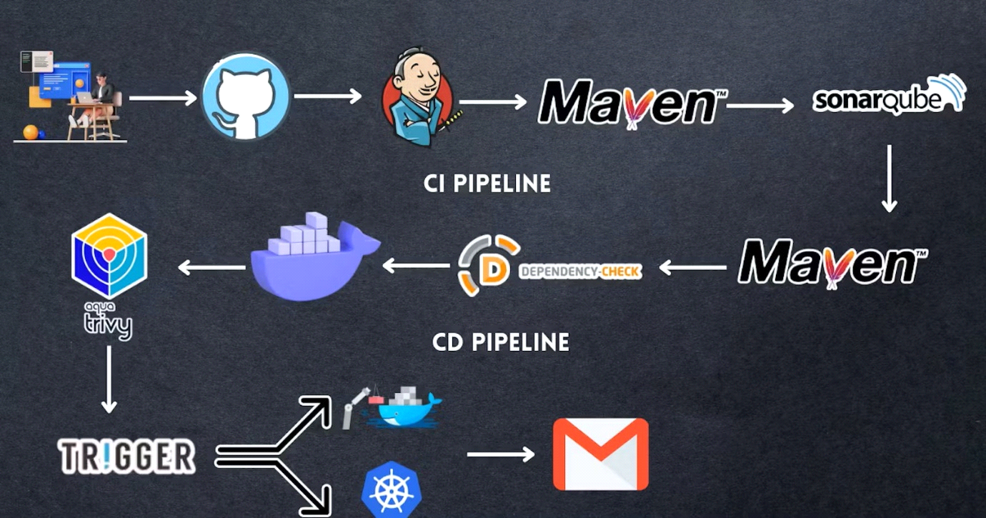

**TABLE OF CONTENTS**

* [STEP1: HYPERLINK "https://mrcloudbook.hashnode.dev/devsecops-project-complete-ci-cd-3-tier-app-petshop" HYPERLINK "https://mrcloudbook.hashnode.dev/devsecops-project-complete-ci-cd-3-tier-app-petshop"Create an HYPERLINK "https://mrcloudbook.hashnode.dev/devsecops-project-complete-ci-cd-3-tier-app-petshop"Ubuntu ( HYPERLINK "https://mrcloudbook.hashnode.dev/devsecops-project-complete-ci-cd-3-tier-app-petshop"22.04) T2 Large Instance](https://mrcloudbook.hashnode.dev/devsecops-project-complete-ci-cd-3-tier-app-petshop)
* [Step 2 — Install Jenkins, Docker and Trivy](https://mrcloudbook.hashnode.dev/devsecops-project-complete-ci-cd-3-tier-app-petshop)
* [2A — To Install Jenkins](https://mrcloudbook.hashnode.dev/devsecops-project-complete-ci-cd-3-tier-app-petshop)
* [2B — Install Docker](https://mrcloudbook.hashnode.dev/devsecops-project-complete-ci-cd-3-tier-app-petshop)
* [2C — Install Trivy](https://mrcloudbook.hashnode.dev/devsecops-project-complete-ci-cd-3-tier-app-petshop)
* [Step 3 — Install Plugins like JDK, HYPERLINK "https://mrcloudbook.hashnode.dev/devsecops-project-complete-ci-cd-3-tier-app-petshop"SonarQube HYPERLINK "https://mrcloudbook.hashnode.dev/devsecops-project-complete-ci-cd-3-tier-app-petshop" Scanner, Maven, OWASP Dependency Check](https://mrcloudbook.hashnode.dev/devsecops-project-complete-ci-cd-3-tier-app-petshop)
* [3A — Install Plugin](https://mrcloudbook.hashnode.dev/devsecops-project-complete-ci-cd-3-tier-app-petshop)
* [3B — Configure Java and Maven in Global Tool Configuration](https://mrcloudbook.hashnode.dev/devsecops-project-complete-ci-cd-3-tier-app-petshop)
* [3C — Create a Job](https://mrcloudbook.hashnode.dev/devsecops-project-complete-ci-cd-3-tier-app-petshop)
* [Step 4 — Configure Sonar Server in Manage Jenkins](https://mrcloudbook.hashnode.dev/devsecops-project-complete-ci-cd-3-tier-app-petshop)
* [Step 5 — Install OWASP Dependency Check Plugins](https://mrcloudbook.hashnode.dev/devsecops-project-complete-ci-cd-3-tier-app-petshop)
* [Step 6 — Docker Image Build and Push](https://mrcloudbook.hashnode.dev/devsecops-project-complete-ci-cd-3-tier-app-petshop)
* [Step 8 — HYPERLINK "https://mrcloudbook.hashnode.dev/devsecops-project-complete-ci-cd-3-tier-app-petshop"Kubernetes HYPERLINK "https://mrcloudbook.hashnode.dev/devsecops-project-complete-ci-cd-3-tier-app-petshop" Setup](https://mrcloudbook.hashnode.dev/devsecops-project-complete-ci-cd-3-tier-app-petshop)
* [Kubectl on Jenkins to be installed](https://mrcloudbook.hashnode.dev/devsecops-project-complete-ci-cd-3-tier-app-petshop)
* [Part 1 ----------Master Node------------](https://mrcloudbook.hashnode.dev/devsecops-project-complete-ci-cd-3-tier-app-petshop)
* [----------Worker Node------------](https://mrcloudbook.hashnode.dev/devsecops-project-complete-ci-cd-3-tier-app-petshop)
* [Part 2 ------------Both Master HYPERLINK "https://mrcloudbook.hashnode.dev/devsecops-project-complete-ci-cd-3-tier-app-petshop"& HYPERLINK "https://mrcloudbook.hashnode.dev/devsecops-project-complete-ci-cd-3-tier-app-petshop" Node ------------](https://mrcloudbook.hashnode.dev/devsecops-project-complete-ci-cd-3-tier-app-petshop)
* [Part 3 --------------- Master ---------------](https://mrcloudbook.hashnode.dev/devsecops-project-complete-ci-cd-3-tier-app-petshop)
* [----------Worker Node------------](https://mrcloudbook.hashnode.dev/devsecops-project-complete-ci-cd-3-tier-app-petshop)
* [Configuring mail server in Jenkins ( Gmail )](https://mrcloudbook.hashnode.dev/devsecops-project-complete-ci-cd-3-tier-app-petshop)
* [STEP9:Access from a Web browser with](https://mrcloudbook.hashnode.dev/devsecops-project-complete-ci-cd-3-tier-app-petshop)
* [Step 10: Terminate instances.](https://mrcloudbook.hashnode.dev/devsecops-project-complete-ci-cd-3-tier-app-petshop)
* [Complete Pipeline](https://mrcloudbook.hashnode.dev/devsecops-project-complete-ci-cd-3-tier-app-petshop)
* [Trigger code](https://mrcloudbook.hashnode.dev/devsecops-project-complete-ci-cd-3-tier-app-petshop)
* [CI- HYPERLINK "https://mrcloudbook.hashnode.dev/devsecops-project-complete-ci-cd-3-tier-app-petshop"pet shop HYPERLINK "https://mrcloudbook.hashnode.dev/devsecops-project-complete-ci-cd-3-tier-app-petshop"-pipeline](https://mrcloudbook.hashnode.dev/devsecops-project-complete-ci-cd-3-tier-app-petshop)
* [CD- HYPERLINK "https://mrcloudbook.hashnode.dev/devsecops-project-complete-ci-cd-3-tier-app-petshop"pet shop HYPERLINK "https://mrcloudbook.hashnode.dev/devsecops-project-complete-ci-cd-3-tier-app-petshop"-pipeline](https://mrcloudbook.hashnode.dev/devsecops-project-complete-ci-cd-3-tier-app-petshop)

Hello friends, we will be deploying a Pet shop Java Based Application. This is an everyday use case scenario used by several organizations. We will be using Jenkins as a CICD tool and deploying our application on a Docker container and Kubernetes cluster. Hope this detailed blog is useful.

We will be deploying our application in two ways, one using Docker Container and the other using K8S cluster.

Project Repo:  https://github.com/Venn1991/jpetstore-6.git

**Steps:-**

Step 1 — Create an Ubuntu(22.04) T2 Large Instance

Step 2 — Install Jenkins, Docker and Trivy. Create a SonarQube Container using Docker.

Step 3 — Install Plugins like JDK, SonarQube Scanner, Maven, and OWASP Dependency Check.

Step 4 — Create a Pipeline Project in Jenkins using a Declarative Pipeline

Step 5 — Install OWASP Dependency Check Plugins

Step 6 — Docker Image Build and Push

Step 7 — Deploy the image using Docker

Step 8 — Kubernetes master and slave setup on Ubuntu (20.04)

Step 9 — Access the Real-World Application

Step 10 — Terminate the AWS EC2 Instances.

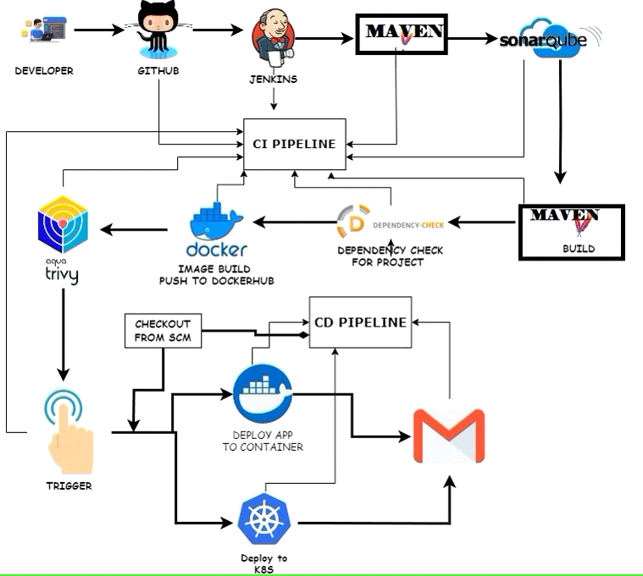

STEP1: Create an Ubuntu (22.04) T2 Large Instance

Launch an AWS T2 Large Instance. Use the image as Ubuntu. You can create a new key pair or use an existing one. Enable HTTP and HTTPS settings in the Security Group and open all ports (not best case to open all ports but just for learning purposes it's okay).

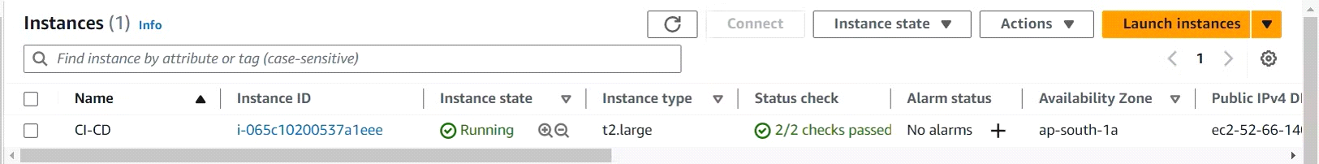

Step 2 — Install Jenkins, Docker and Trivy

2A — To Install Jenkins

Connect to your console, and enter these commands to Install Jenkins

**vi jenkins.sh**

**#!/bin/bash**

**sudo apt update -y**

**#sudo apt upgrade -y**

**wget -O -** [**https://packages.adoptium.net/artifactory/api/gpg/key/public**](https://packages.adoptium.net/artifactory/api/gpg/key/public) **| tee /etc/apt/keyrings/adoptium.asc**

**"deb [signed-by=/etc/apt/keyrings/adoptium.asc]** [**https://packages.adoptium.net/artifactory/deb**](https://packages.adoptium.net/artifactory/deb) **$(awk -F= '/^VERSION_CODENAME/{print$2}' /etc/os-release) main" | tee /etc/apt/sources.list.d/adoptium.list**

**sudo apt update -y**

**sudo apt install temurin-17-jdk -y**

**sudo apt install maven -y**

**/usr/bin/java --version**

**curl -fsSL** [**https://pkg.jenkins.io/debian-stable/jenkins.io-2023.key**](https://pkg.jenkins.io/debian-stable/jenkins.io-2023.key) **| sudo tee \**

**/usr/share/keyrings/jenkins-keyring.asc > /dev/null**

**echo deb [signed-by=/usr/share/keyrings/jenkins-keyring.asc] \**

[**https://pkg.jenkins.io/debian-stable binary/**](https://pkg.jenkins.io/debian-stable%20binary/) **| sudo tee \**

**/etc/apt/sources.list.d/jenkins.list > /dev/null\**

**Sudo apt-get update -y**

**sudo apt-get install jenkins -y**

**sudo sytemctl start jenkins**

**sudo systemctl status Jenkins**

**sudo chmod 777 jenkins.sh**

**./jenkins.sh # this will installl Jenkins**

Once Jenkins is installed, you will need to go to your AWS EC2 Security Group and open Inbound Port 8080, since Jenkins works on Port 8080.

But for this Application case, we are running Jenkins on another port. 5so change the port to 8090 using the below commands.

**sudo systemctl stop jenkins**

**sudo systemctl status jenkins**

**cd /etc/default**

**sudo vi jenkins #chnage port HTTP_PORT=8090 and save and exit**

**cd /lib/systemd/system**

**sudo vi jenkins.service #change Environments="Jenkins_port=8090" save and exit**

**sudo systemctl daemon-reload**

**sudo systemctl restart jenkins**

**sudo systemctl status Jenkins**

Now, grab your Public IP Address

**<EC2 Public IP Address:8090>**

**sudo cat /var/lib/jenkins/secrets/initialAdminPassword**

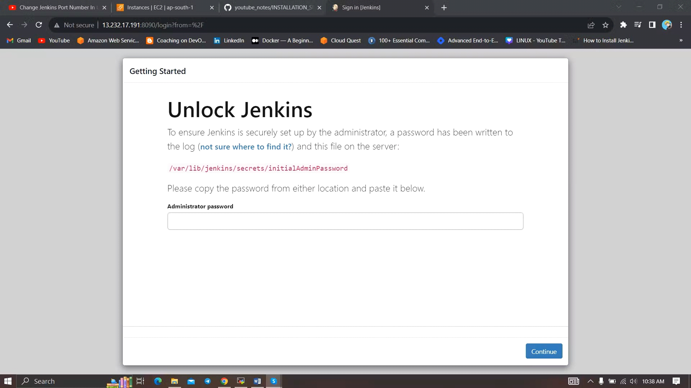

Unlock Jenkins using an administrative password and install the suggested plugins.

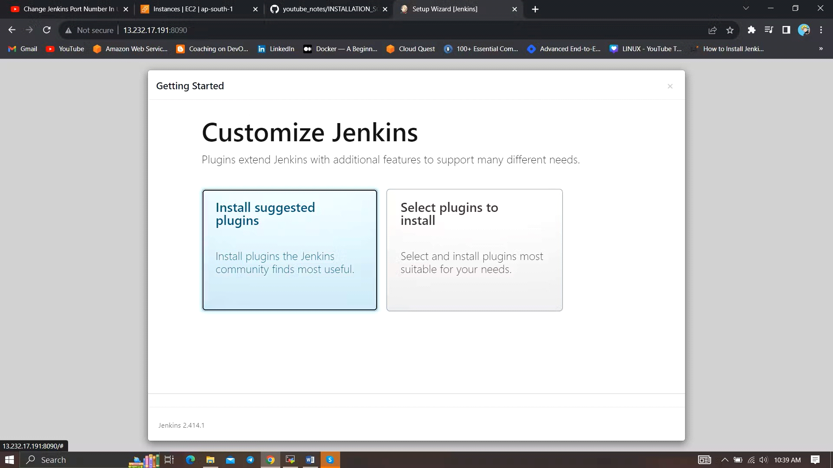

Jenkins will now get installed and install all the libraries. 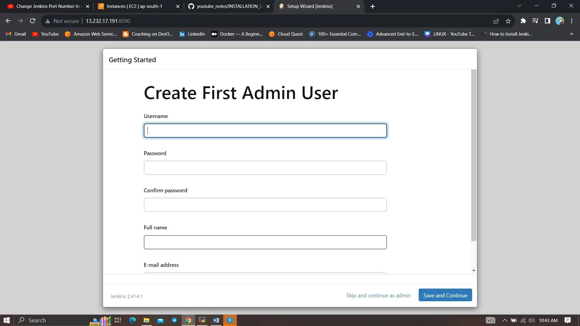

Create a user click on save and continue.

Jenkins Getting Started Screen.

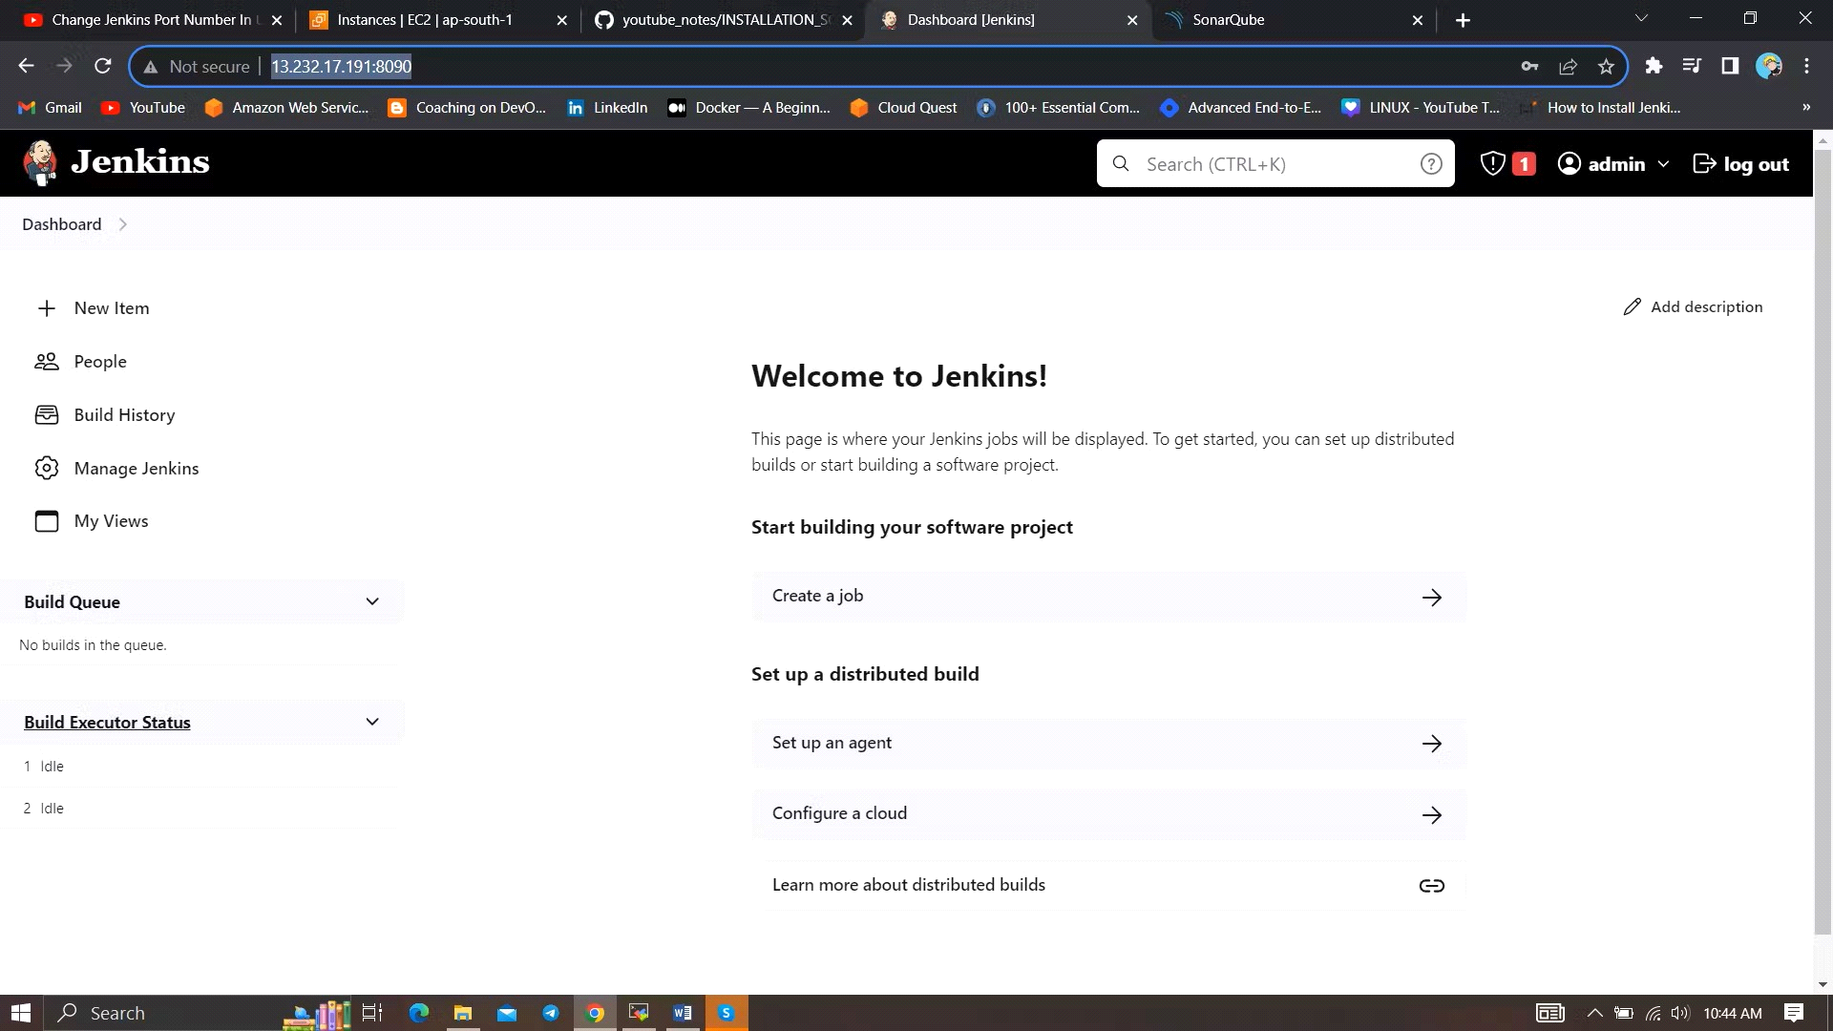

docker

2B — Install Docker

sudo apt-get update

sudo apt-get install docker.io -y

sudo usermod -aG docker $USER #my case is ubuntu

newgrp docker

sudo chmod 777 /var/run/docker.sock

After the docker installation, we create a sonarqube container (Remember added 9000 ports in the security group

docker run -d --name sonar -p 9000:9000 sonarqube:lts-community

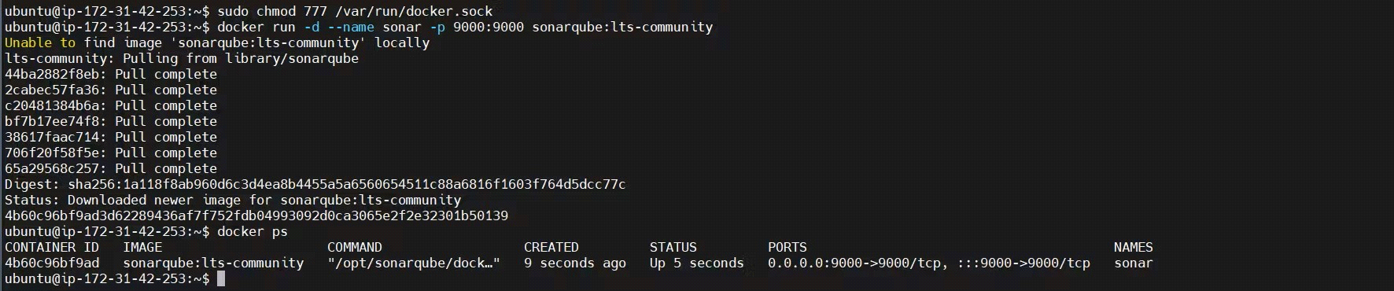

Now our SonarQube is up and running

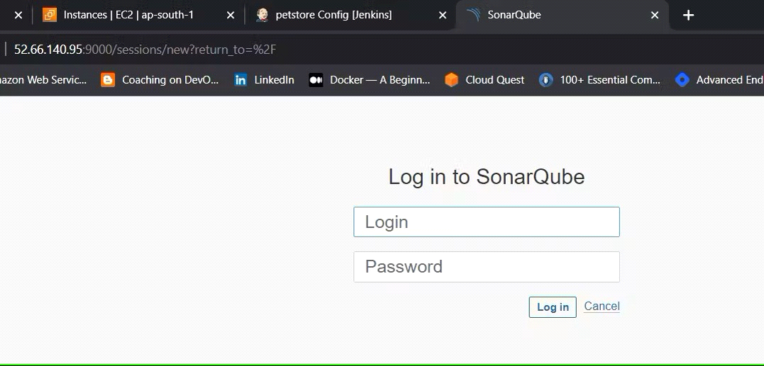

Enter username and password, click on login and change password

username admin

password admin

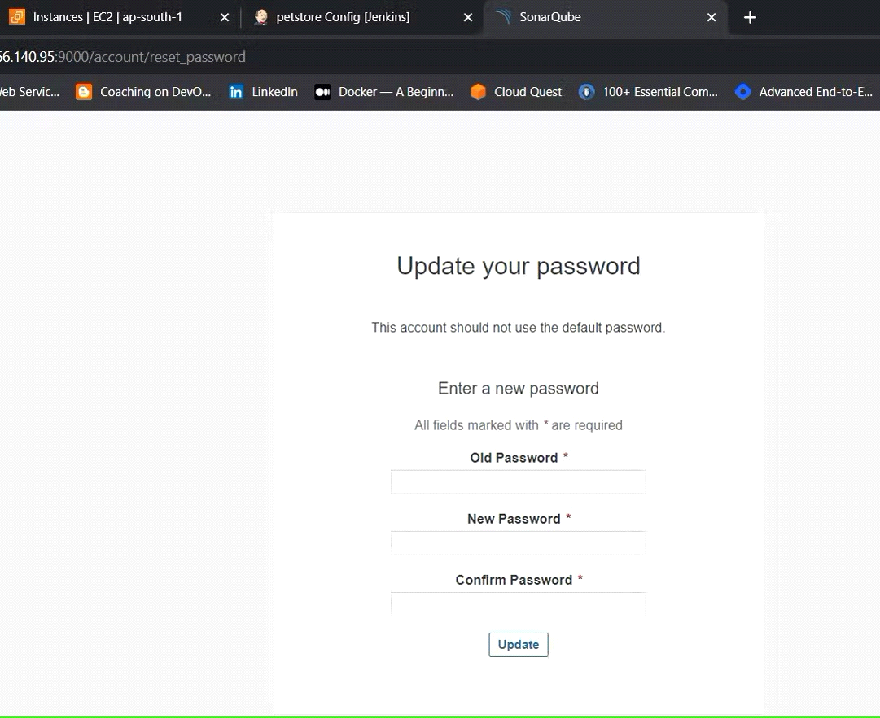

Update New password, This is Sonar Dashboard.

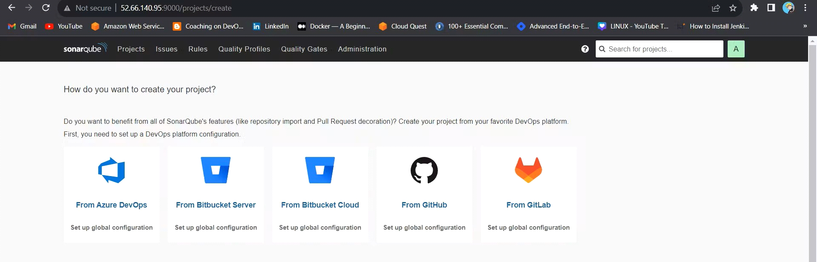

2C — Install Trivy

vi trivy.sh

sudo apt-get install wget apt-transport-https gnupg lsb-release -y

wget -qO - <https://aquasecurity.github.io/trivy-repo/deb/public.key> | gpg --dearmor | sudo tee /usr/share/keyrings/trivy.gpg > /dev/null

echo "deb [signed-by=/usr/share/keyrings/trivy.gpg] <https://aquasecurity.github.io/trivy-repo/deb> $(lsb_release -sc) main" | sudo tee -a /etc/apt/sources.list.d/trivy.list

sudo apt-get update

sudo apt-get install trivy -y

Next, we will log in to Jenkins and start to configure our Pipeline in Jenkins

Step 3 — Install Plugins like JDK, Sonarqube Scanner, Maven, OWASP Dependency Check

3A — Install Plugin

Goto Manage Jenkins →Plugins → Available Plugins →

Install below plugins

1 → Eclipse Temurin Installer (Install without restart)

2 → SonarQube Scanner (Install without restart)

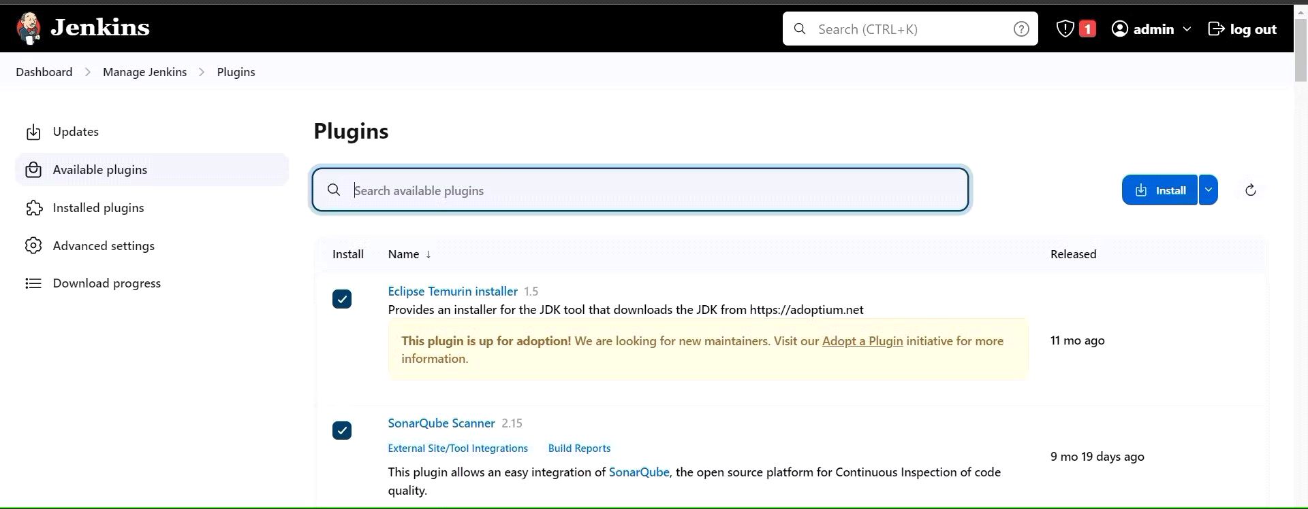

3B — Configure Java and Maven in Global Tool Configuration

Goto Manage Jenkins → Tools → Install JDK(17) and Maven3(3.6.0) → Click on Apply and Save

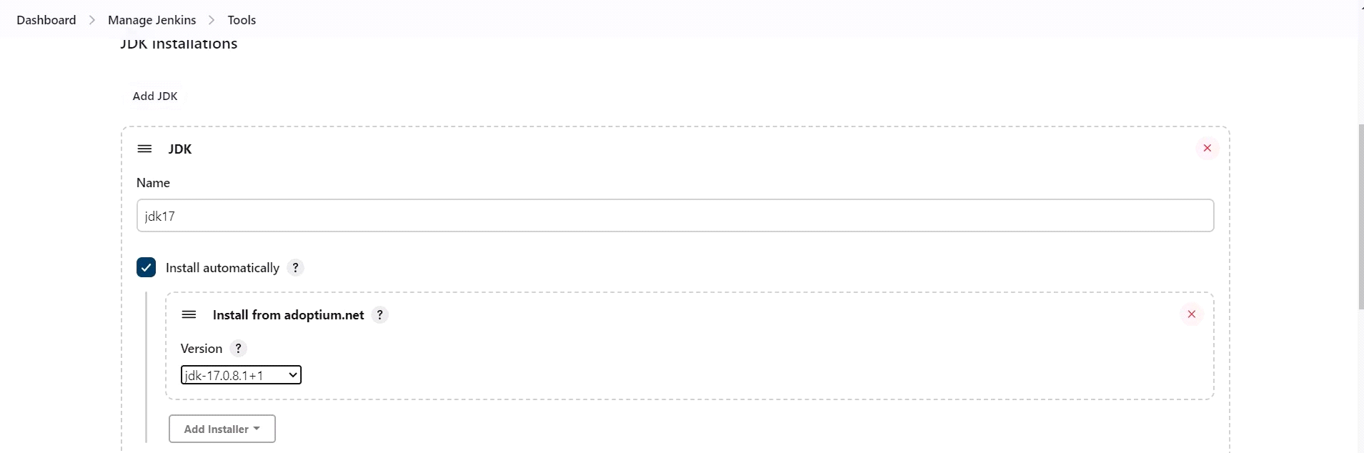

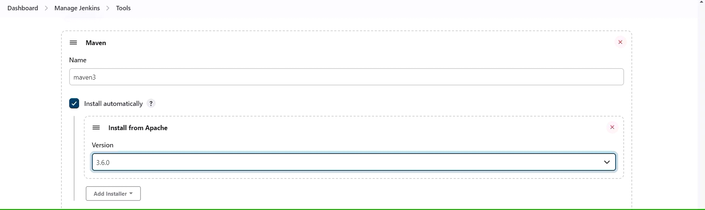

3C — Create a Job

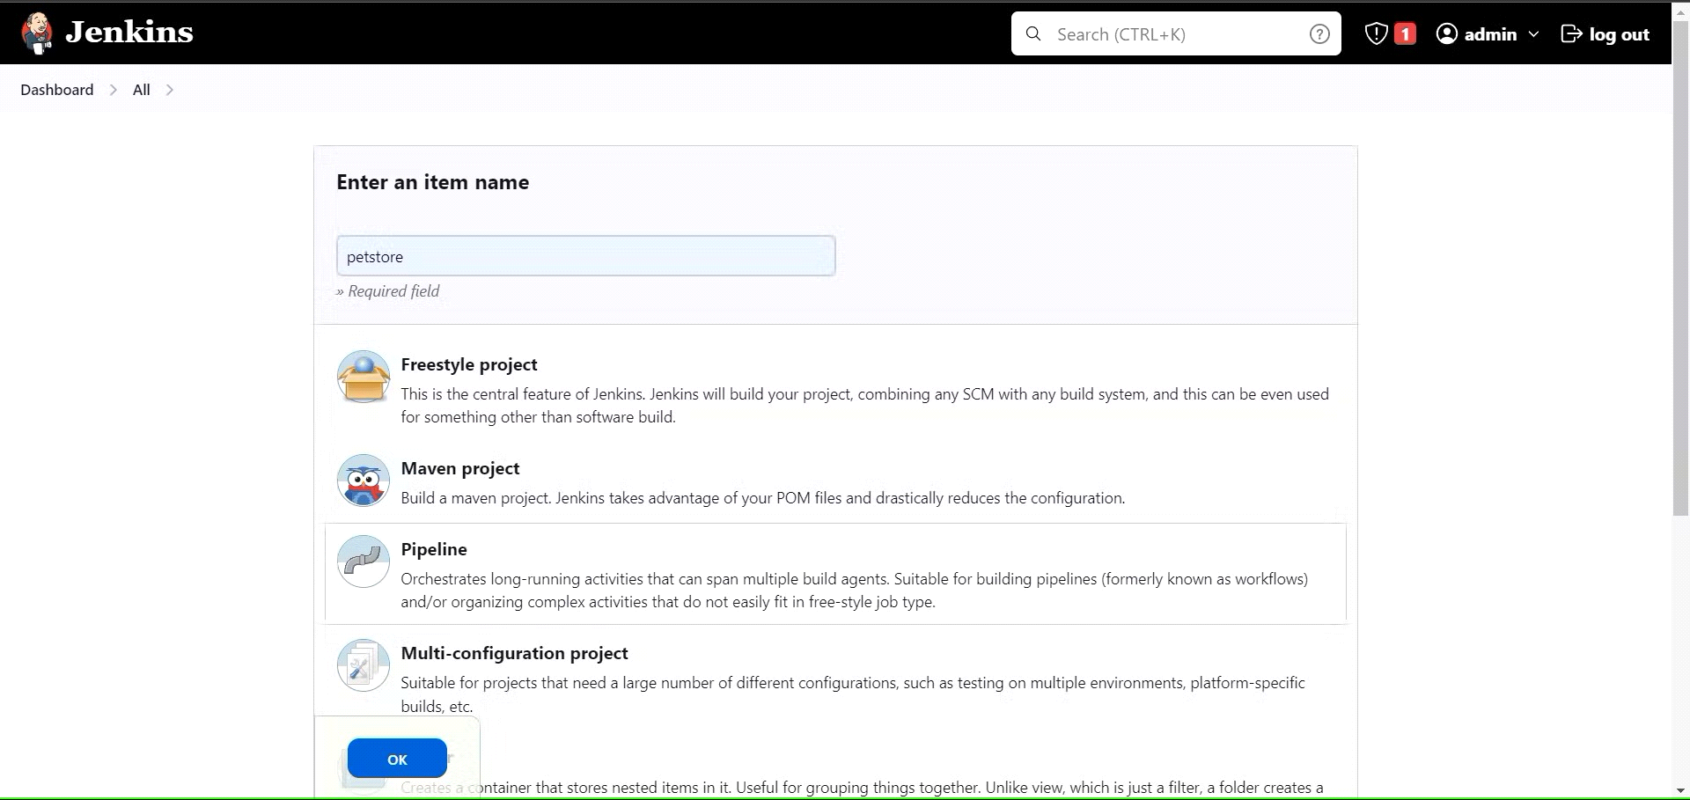

Enter this in Pipeline Script, 15.206.66.134

look like this,

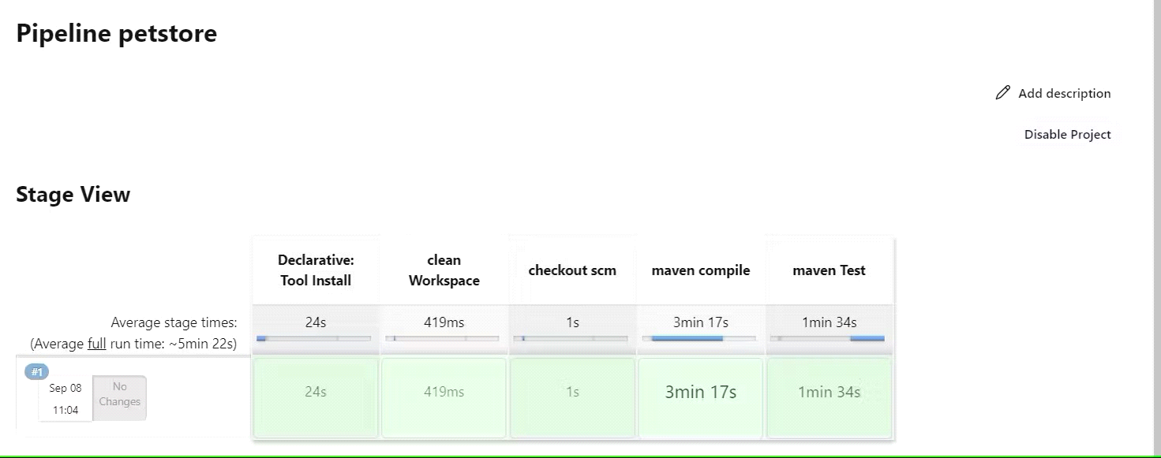

Step 4 — Configure Sonar Server in Manage Jenkins

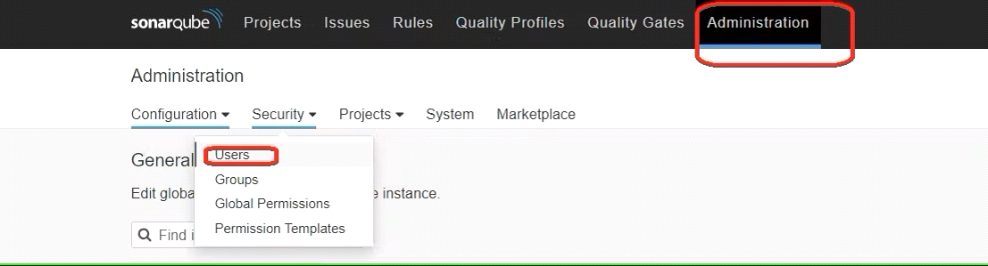

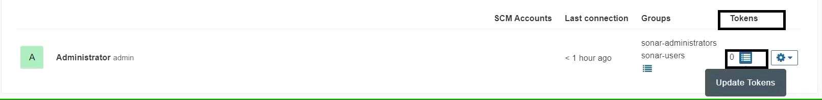

Create a token with a name and generate

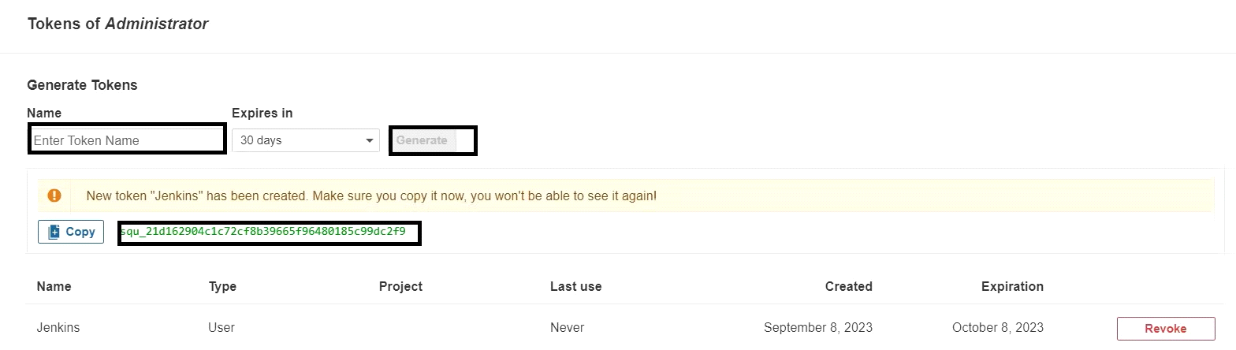

copy Token

Goto Jenkins Dashboard → Manage Jenkins → Credentials → Add Secret Text. It should look like this

\

You will this page once you click on create

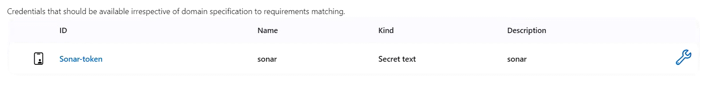

Now, go to Dashboard → Manage Jenkins → System and Add like the below image.

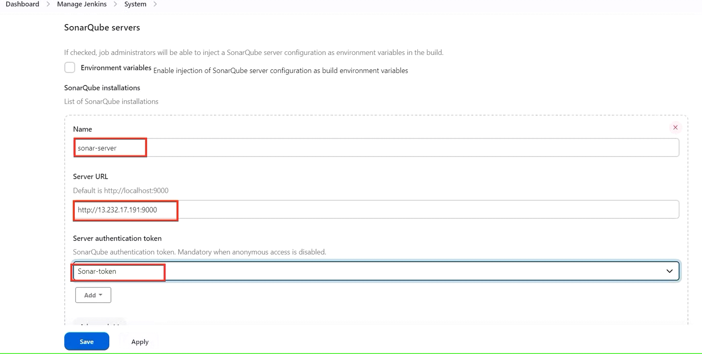

Click on Apply and Save

**The Configure System option** is used in Jenkins to configure different server

**Global Tool Configuration** is used to configure different tools that we install using Plugins

We will install a sonar scanner in the tools.

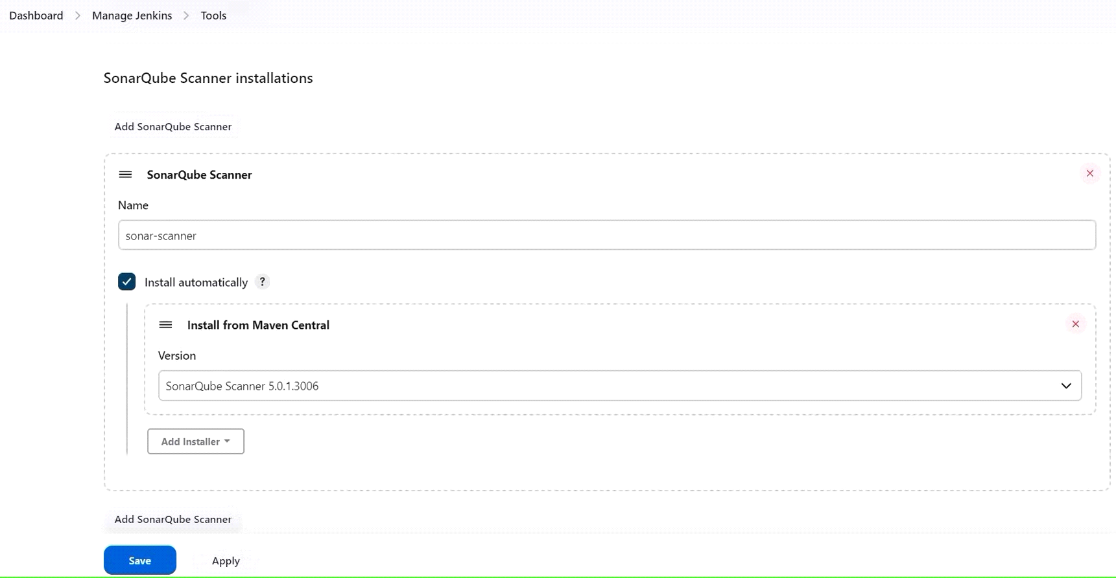

In the Sonarqube Dashboard add a quality gate also

Administration--> Configuration-->Webhooks

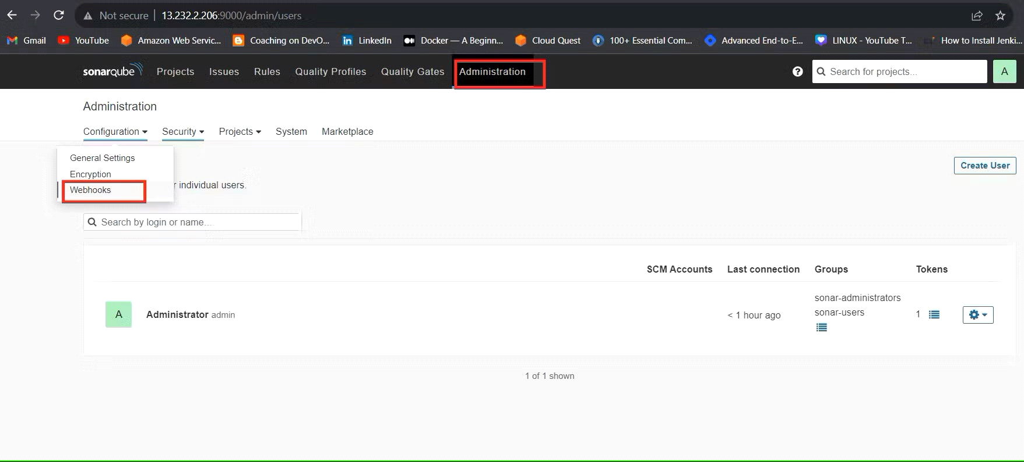

Click on Create

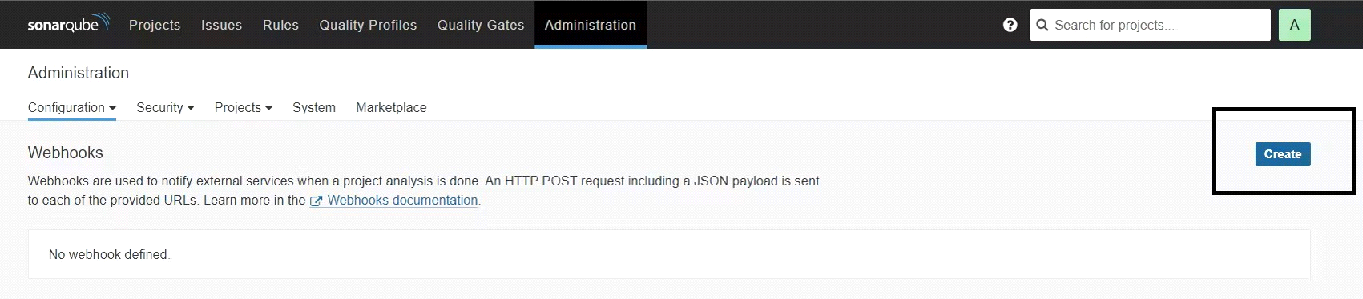

Add details

#in url section of quality gate

<[http://jenkins-public-ip:8090](http://jenkins-public-ip:8090/)>/sonarqube-webhook/

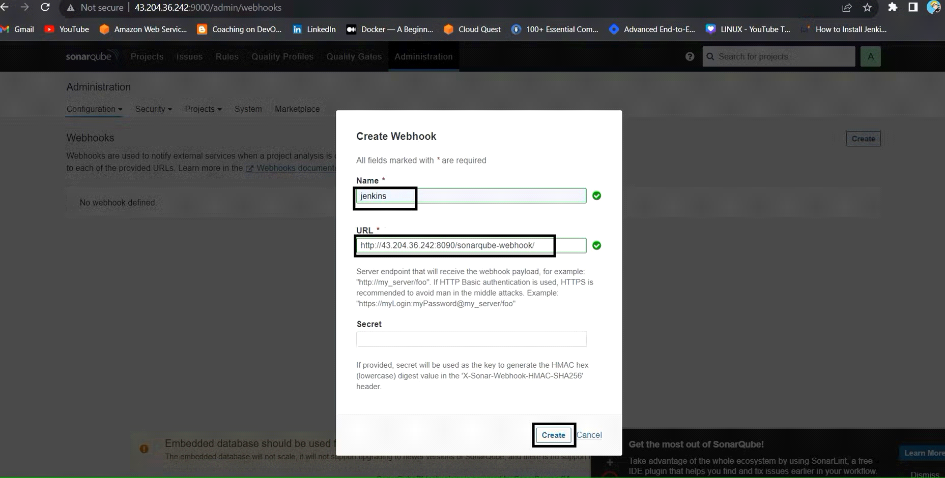

Let's go to our Pipeline and add Sonarqube Stage in our Pipeline Script.

#under tools section add this environment

environment {

SCANNER_HOME=tool 'sonar-scanner'

}

# in stages add this

stage("Sonarqube Analysis "){

steps{

withSonarQubeEnv('sonar-server') {

sh ''' $SCANNER_HOME/bin/sonar-scanner -Dsonar.projectName=Petshop \

-Dsonar.java.binaries=. \

-Dsonar.projectKey=Petshop '''

}

}

}

stage("quality gate"){

steps {

script {

waitForQualityGate abortPipeline: false, credentialsId: 'Sonar-token'

}

}

}

Click on Build now, you will see the stage view like this

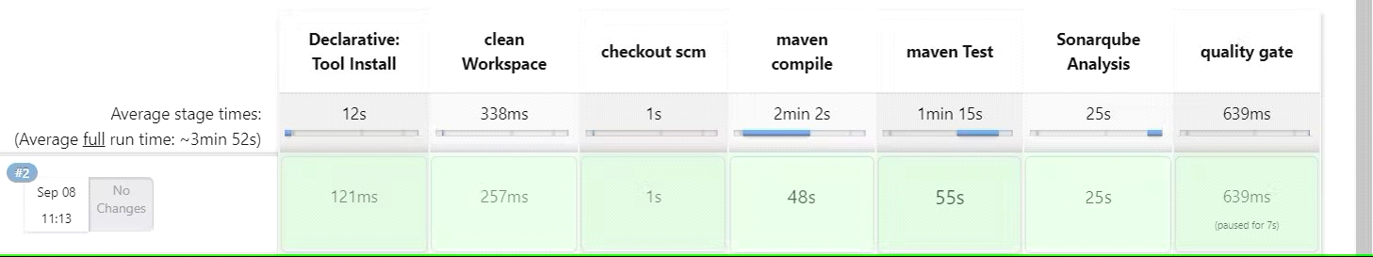

To see the report, you can go to Sonarqube Server and go to Projects.

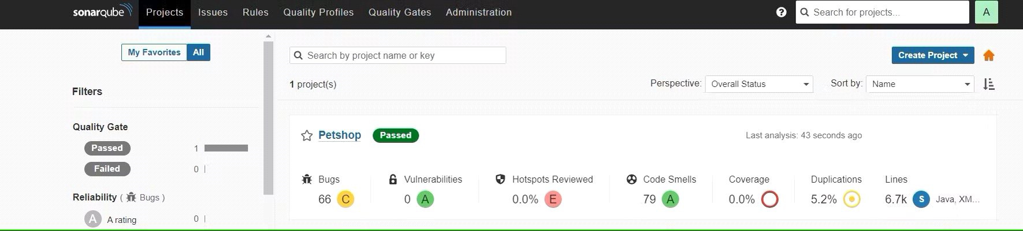

You can see the report has been generated and the status shows as passed. You can see that there are 6.7k lines. To see a detailed report, you can go to issues.

Step 5 — Install OWASP Dependency Check Plugins

GotoDashboard → Manage Jenkins → Plugins → OWASP Dependency-Check. Click on it and install it without restart.

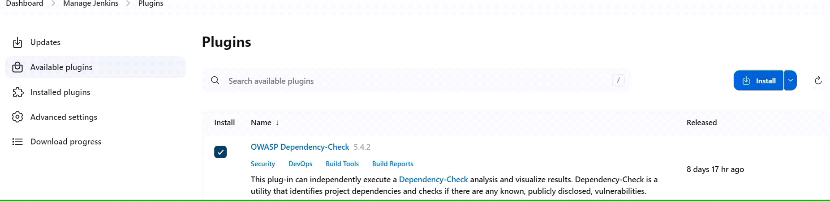

First, we configured the Plugin and next, we had to configure the Tool

Goto Dashboard → Manage Jenkins → Tools →

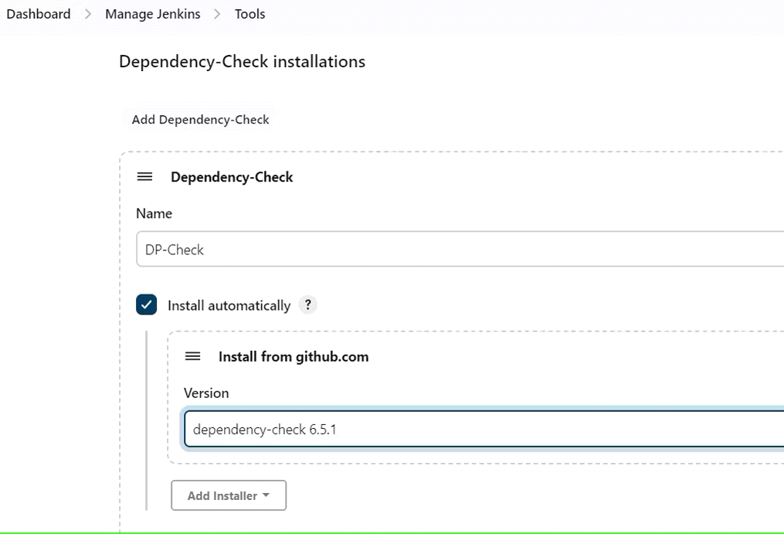

Click on Apply and Save here.

Now go configure → Pipeline and add this stage to your pipeline and build.

stage ('Build war file'){

steps{

sh 'mvn clean install -DskipTests=true'

}

}

stage("OWASP Dependency Check"){

steps{

dependencyCheck additionalArguments: '--scan ./ --format XML ', odcInstallation: 'DP-Check'

dependencyCheckPublisher pattern: '**/dependency-check-report.xml'

}

}

The stage view would look like this,

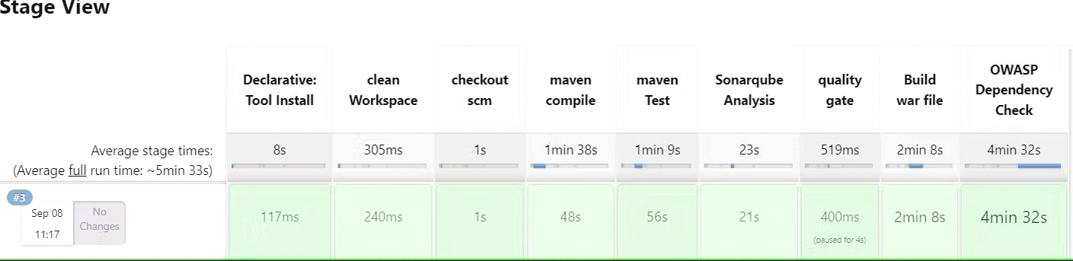

You will see that in status, a graph will also be generated and Vulnerabilities.

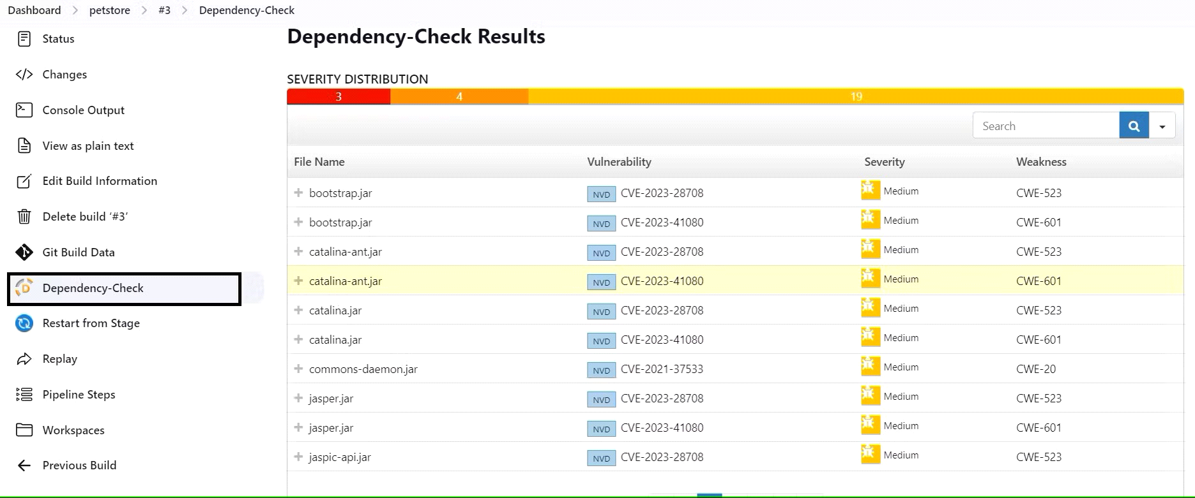

Step 6 — Docker Image Build and Push

We need to install the Docker tool in our system, Goto Dashboard → Manage Plugins → Available plugins → Search for Docker and install these plugins

Docker

Docker Commons

Docker Pipeline

Docker API

docker-build-step

and click on install without restart

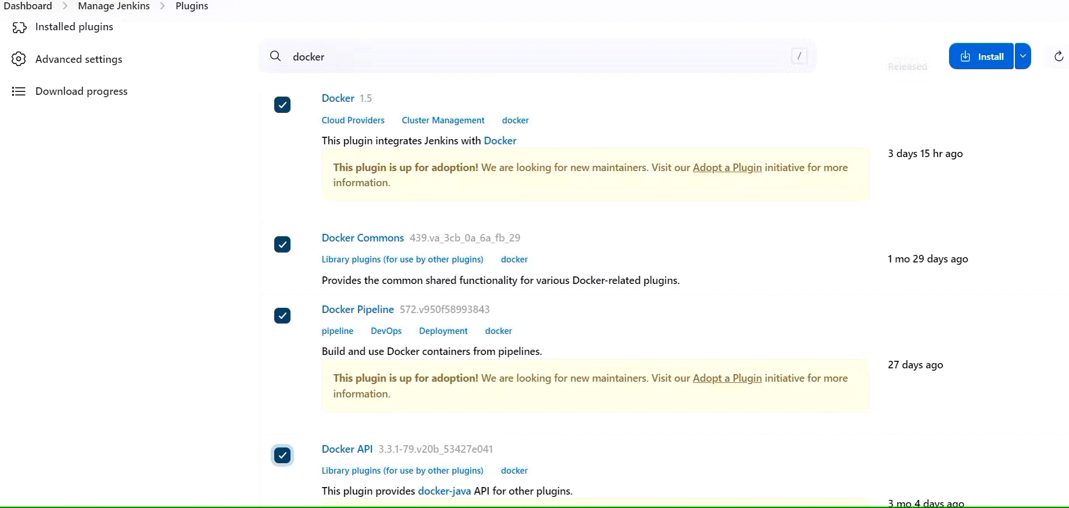

Now, goto Dashboard → Manage Jenkins → Tools →

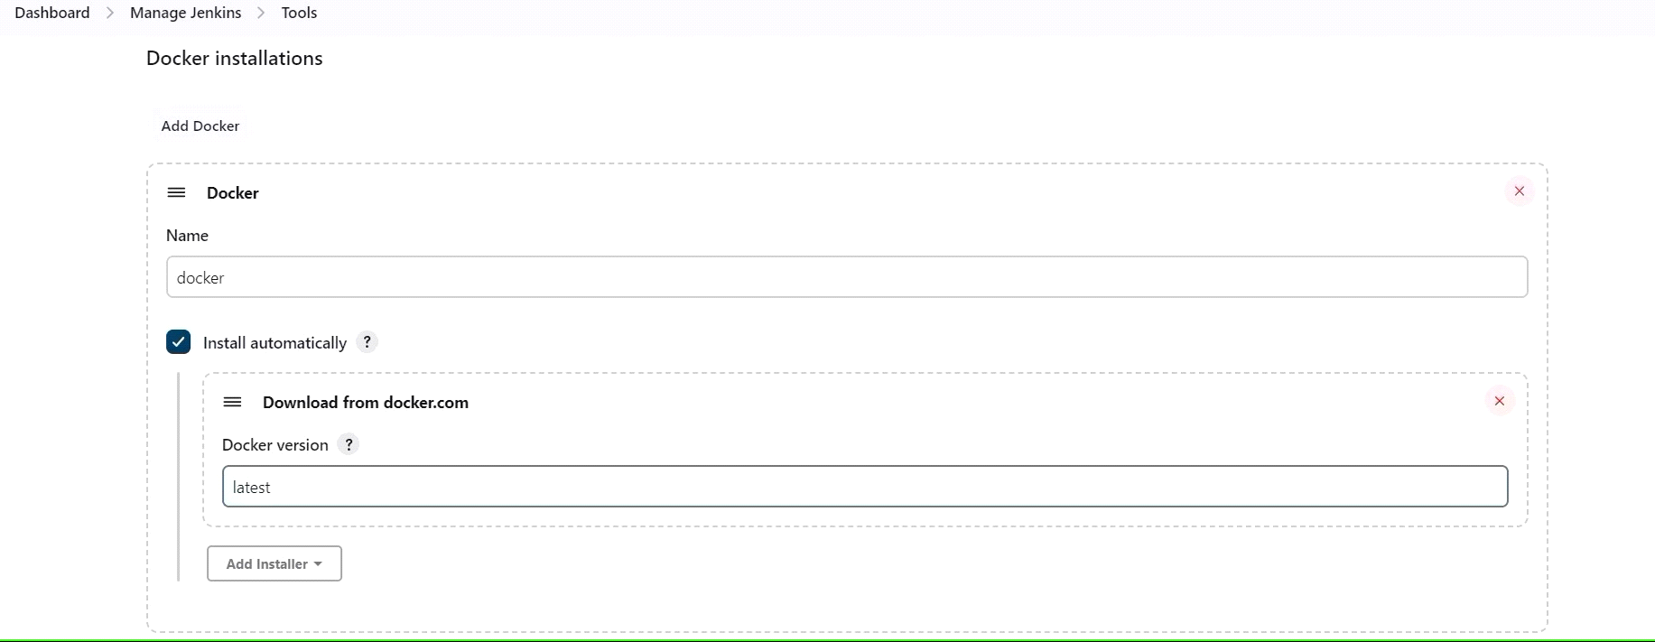

Add DockerHub Username and Password under Global Credentials

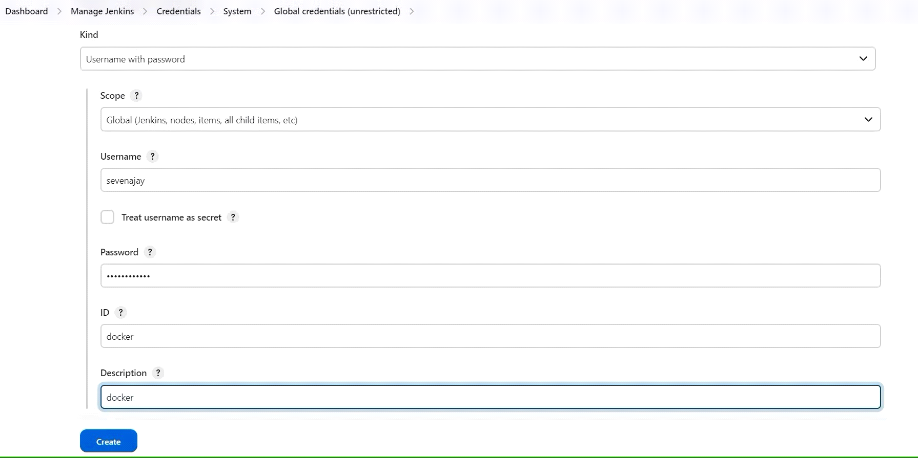

Add this stage to Pipeline Script

stage ('Build and push to docker hub'){

steps{

script{

withDockerRegistry(credentialsId: 'docker', toolName: 'docker') {

sh "docker build -t petshop ."

sh "docker tag petshopimagid devopsvmr/petshop:latest"

sh "docker push devopsvmr/petshop: latest"

}

}

}

}

stage("TRIVY"){

steps{

sh "trivy image devopsvmr/petshop:latest > trivy.txt"

}

}

stage ('Deploy to container'){

steps{

sh 'docker run -d --name pet1 -p 8080:8080 sevenajay/petshop: latest'

}

}

You will see the output below, with a dependency trend.

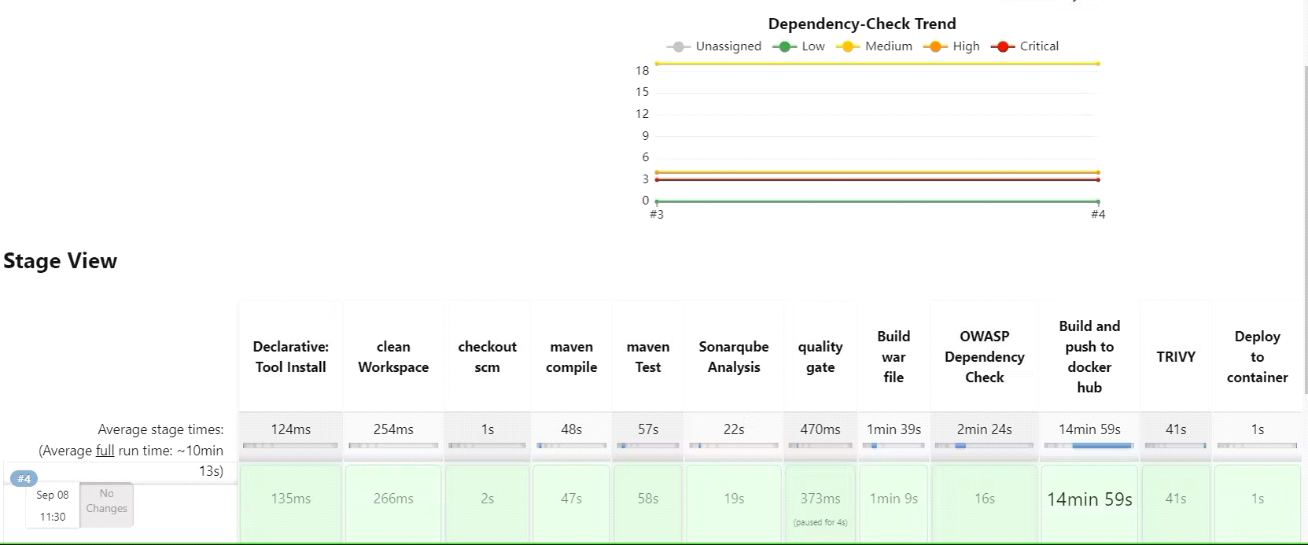

Now, when you do

When you log in to Dockerhub, you will see a new image is created

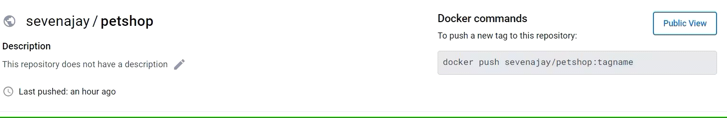

<Ec2-public-ip:8080/jpetstore>

You will get this output

